**OFFICIAL COORDINATION REQUEST FOR**

**NON-ROUTINE OPERATIONS AND MAINTENANCE**

**COORDINATION TITLE -** 15LOP01Spillway Gate Repair

**COORDINATION DATE -** 8 April 2015

**PROJECT -** Lookout Point Dam

**RESPONSE DATE -** 03 May 2016

**UPDATE (19 April 2016): There are only 2 gates left at Lookout Point Dam that need to be worked on (gates 4 and 5). The contractor needs 6 weeks to complete their remaining work and will complete work ahead of schedule from approximately July 15 to September 1.**

**RESPONSE DATE for UPDATE: 03 May 2016**

**Description of the problem**

To ensure Lookout Point can fully perform its mission of helping reduce flood damage to Willamette River communities, the WVP will be rehabilitating the dam’s five spillway gates are structurally deficient from July 2015 through November 2018.

The rehabilitation of the gates requires the work area remain unwatered as much as possible. Lookout Point’s reservoir will be aggressively managed to keep the elevation below 867.5’ msl whenever possible – about 20 feet below the spillway crest and 58 feet below its usual maximum summer elevation.

**Table 1.** Lookout Point elevations and corresponding spillway releases through one spillbay.

|  |  |  |
| --- | --- | --- |
|  | **Elevation1**  **(feet)** | **Single Spillbay Free Flow**  **(cfs)** |
| Top of Dam | 941.0 |  |
| Maximum Pool | 934.0 | 45,500 |
| Maximum Conservation Pool [top of closed spillway gate] | 926.0 | 38,800 |
| IRRM initial elevation [top strut] | 915.0 | 22,300 |
| Spillway Crest | 887.5 | - |
| Minimum Conservation Pool & Winter Flood Control Pool | 825.0 | - |
| Minimum Power Pool | 819.0 | - |
| Regulating Outlet Invert | 724.0 | - |

**Type of outage required**

No spill capabilities from LOP from 15 July through 15 November in 2015. No spill capabilities from LOP from 15 September to 15 November in 2017 – 2018. During 2016 where spill gate work will occur from July 15 to approximately September 1.

**Impact on facility operation**

Keeping the spillway gates in the dry may result in higher flows for longer durations following significant rain events; however, the goal remains to regulate to bankfull downstream. The project releases will be managed aggressively during an event and when evacuating stored water after an event. While the regulation goal at the control point is 20,000 cfs, the project may need to manage to up to 23,000 cfs at the downstream control point if meteorological conditions allow. A goal of regulation will be to get the pool back down below spillway crest to minimize delays to the Contractor since some repairs cannot be conducted while the gate is hydraulically loaded.

**Dates of impacts/repairs**

The construction window is a tradeoff of potential consequences based on risks associated with each window. The recommended construction window to repair two spillway gates at Lookout Point, based on the best information available, appears to be 15 July to 15 November in 2015. In subsequent years, one additional gate will be rehabilitated from 15 September to 15 November, with the last gate being having an anticipated completion date of 15 November 2018.

If the construction window can be shortened from the existing 16 weeks in 2015 (eight weeks per gate) the start date would be shifted later while maintaining the end date of 15 November.

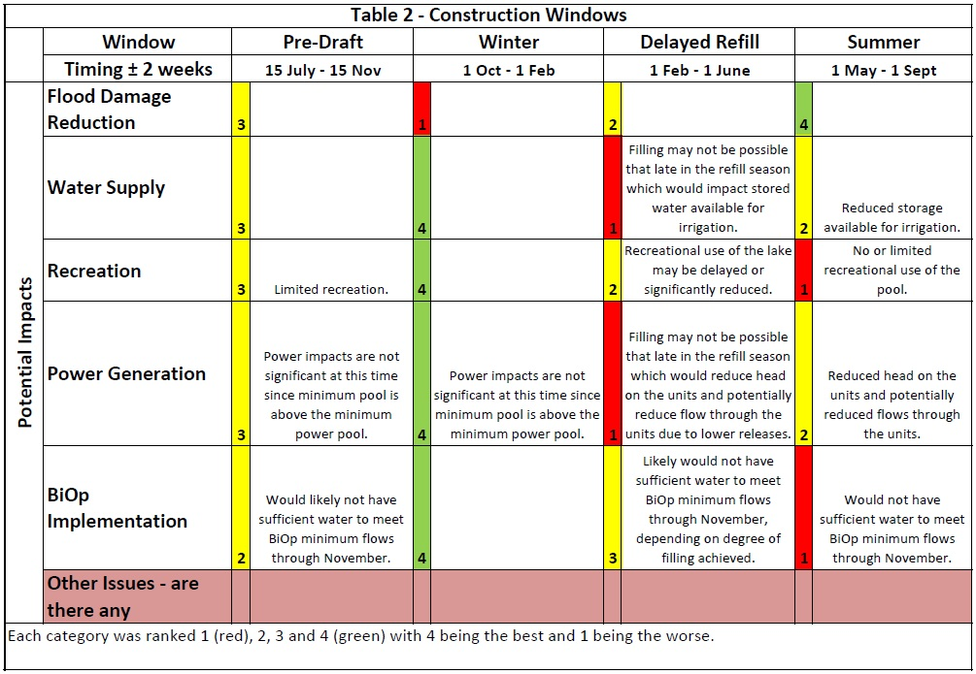

**Table 3.** Annual probability event during which inflow exceeds the Lookout Point RO capacity.

|  |  |  |  |
| --- | --- | --- | --- |
| **Month** | **Annual Probability Event (%)** | **Month** | **Annual Probability Event (%)** |
| October | 0.2 | April | 0.2 |
| November | 5 | May | 0.2 |
| December | 10 | June | 0.2 |
| January | 10 | July | 0.2 |
| February | 5 | August | 0.2 |
| March | 1 | September | 0.2 |

**Length of time for repairs**

Based on previous repairs made at Foster, Dexter, and Big Cliff the Contractor will need approximately eight weeks to repair the structural deficiencies and the trunnion. A 16-week construction window is expected; two gates at eight weeks per gate for 2015.

**Expected impacts on fish**

Keeping the reservoir below the spillway crest will prevent regulating downriver water temperatures. This is usually done in the summer by mixing warmer water from the spillway with colder water from the powerhouse or regulating outlets.

The beneficial use of the stored water in the Willamette Valley Project reservoirs has been used for interim temperature management operations as part of the Willamette Biological Opinions (BiOps). From a BiOp perspective, the Winter (1 Oct – 1 Feb) construction window is the best option since the reservoir is already drafted during this period. However, the probability of not being able to pass inflows is too high from a human safety perspective (Table 3). Earlier drafting will impact the ability of the project to meet BiOp flow objectives, most notably in this first year of rehabilitation.

**Comments from agencies-**

The Agencies were notified of this item and it was discussed at the March HMT meeting. From the minutes:

“Gate repairs at Lookout Point. Traylor said this is the type of event that would require a coordination form. No one believes a form was completed for this work… Sharpe expressed concern about the need for medicated feed but there needs to be a need. Peck said it wouldn’t be until late summer until the feed would be needed. He said he has enough medicated feed on hand to treat twice but if he needs to treat fish several times or more then he doesn’t have nearly enough. Traylor will expect a request for funds for medicated feed in late summer if fish show signs of disease. Sharpe suggested there may be options out there to move fish.”

**Final results-**

Please email or call with questions or concerns.

Thank you,

Andy Traylor

NWP Operations Division Fishery Section

C 503 201 5810

O 503 808 4305

[Andrew.W.Traylor@usace.army.mil](mailto:Andrew.W.Traylor@usace.army.mil)